**Real Time Heart Disease Monitoring System**

**Md. Solaiman Hosen**

**ID: 2014–3–60–044**

**Hasan Mahmud**

**ID: 2014–2–60–021**

**A thesis submitted in partial fulfillment of the requirements for the degree of Bachelor of Science in Computer Science and Engineering**



**Department of Computer Science and Engineering**

**East West University**

**Dhaka-1212, Bangladesh**

# April, 2018

**Declaration**

We, hereby, declare that the work presented in this thesis is the outcome of the investigation performed by us under the supervision of Dr. Ahmed Wasif Reza, Professor, Department of Computer Science and engineering, East West University. We also declare that no part of this thesis/project has been or is being submitted elsewhere for the award of any degree or diploma.

Countersigned Signature

. . . . . . . . . . . . . . . . . . . . . . . . . . . . . . . . . . . . . . . . . . . . . . . .

Dr. Ahmed Wasif Reza Md. Solaiman Hosen

Associate Professor & Chairperson ID: 2014-3-60-044

Department of Computer Science & Engineering

Signature

. . . . . . . . . . . . . . . . . . . . . .

Hasan Mahmud

ID: 2014-2-60-021

**Abstract**

During the recent decade, rapid advancements in healthcare services and low cost wireless communication have greatly assisted in coping with the problem of fewer medical facilities. The main purpose of this research work is to develop a wireless sensor network system that can continuously monitor and detect cardiovascular disease experienced in patients at remote areas. One of the most prevalent healthcare problems today is the poor survival rate of out-of-hospital sudden cardiac arrests. The Objective of this study is to present a Wearable Body Area Network System to continuously capture and sent the ECG signal to patient’s Mobile Phone. By analyzing the signal critical situation will be identified and alert will be sent to doctor, relatives and Ambulance services using data processing algorithm implemented on patient’s mobile phone. A wireless transmission system is also proposed for continuous data transmitting to a server system where a doctor can monitor the patient Electrocardiography (ECG) from a long distance. In this project we developed a wearable ECG device and a real time Brachycardia, tachycardia, and sinus arrhythmia detection based android mobile application. ECG signals from patient’s body is collected by the mini ECG device and sent through a Bluetooth module to Android Mobile Application. On Android application processed data analysis based Pan Tompkins algorithms to detect complex QRS ECG signal and heart beats. From the number of heart rate can be detected abnormalities. Upon completing the system, we tested the system using signals generated by Fluke PS400 and real data. There are three categories of abnormalities under study: Brachycardia, tachycardia, and sinus arrhythmia. Normal heart signal is also included in the test. We have tested this application in real time by collecting the ECG from the patient in stationary as well as simulated data. In both situations the application fulfills requirements of the proposed system.

**Acknowledgement**

As a human being we have always run after our goal. We have also arrived at this point of achieving a goal in our life through various interactions with and help from other people. However, written words are often elusive and harbor diverse interpretations even in one’s mother language. Therefore, we would not like to make efforts to find best words to express my thankfulness other than simply listing those people who have contributed to this thesis itself in an essential way. This work was carried out in the Department of Computer Science and Engineering at East West University, Bangladesh.

First, we would like to express my deepest gratitude to the Almighty for His blessings on us. Next, our special thanks go to our supervisor, “Dr. Ahmed Wasif Reza”, who gave us this opportunity, initiated us into the field of “Real Time Heart Diseases Monitoring System”, and without whom this work would not have been possible. His encouragements, visionaries and thoughtful comments and suggestions, unforgettable support at every stage of our B.Sc. study were simply appreciating and essential. His ability to muddle us enough to finally answer our own question correctly is something valuable what we have learned, and we would try to emulate, if ever we get the opportunity.

We would like to thank “Our own team” for excellent collaboration during performance evaluation studies. Last but not the least; we would like to thank our parents for their unending support, encouragement and prayers.

There are numerous other people too who have shown me their constant support and friendship in various ways, directly or indirectly related to our academic life. We will remember them in our heart and hope to find a more appropriate place to acknowledge them in the future.

Md. Solaiman Hosen

April 2018

Hasan Mahmud

April 2018

**Table of Contents**

1. **Chapter 1: Introduction**……...………………………………………………………….1
   1. Real Time Patient Monitoring…………………………………………......................1
   2. Motivation……………………………………………………………………………2
   3. Problem Statement…………………………………………………………………...3
   4. Objective………………………………………………………………......................4
   5. Thesis Organization…………………………………………………….....................4
2. **Chapter 2: Literacy Review**…………………………………………….........................5
   1. Overview of Arduino………………………………………………...........................5
      1. Arduino Uno………...…………………………………………......................6
      2. Specification of Arduino Uno………………………………….…………….7
      3. Power Supply……………………………………………………...................8
      4. Power Pins………………………………………………………...................8
      5. Memory……………………………………………………….……………..9
      6. Input and Output Pins……………………………………………………….9
      7. LED’s………………………………………………..……….…………….11
   2. Biomedical Sensor Pad………………………………………………....................12
      1. Features of Biomedical Sensor Pad…...…………………………………...13
   3. Sensor Cable - Electrode Pads…………………………………………………….13
      1. Features of Sensor Cable - Electrode Pads …..............................................14
   4. Single Lead Heart Rate Monitoring – AD8232…………………………………...15
      1. Pin Connections……………………………………………………………16
      2. Features of AD8232……………………………………………..................17
   5. HC-05 Bluetooth Module…………………………………………………………18
      1. About Bluetooth Module HC-05….......…………………….…..................18
      2. Bluetooth Module Pins…………………………………………………….19
      3. Features of Bluetooth Module…………………………………..................20
   6. Survey of Existing Techniques………………………………………....................21
3. **Chapter 3: Design and Methodology**………………………………………………….24
   1. Healthcare Applications…………………………………………..............................24
      1. Heart Rate Monitoring………………………………………….....................24
   2. Design Specification and Hardware…………………………………………………25
   3. Hardware Connection……………………………………………………………….26
      1. Single Lead Heart Rate Monitor-AD8232…………………………………...26
      2. Sensor Cable-Electrode Pads………………………………………………...28
      3. Biomedical Sensor Pads……………………………………………………...28
      4. HC-05 Bluetooth Module……………………………………………………29
      5. Software Features……………………………………………….....................29
   4. Circuit Diagram………………………………………………………......................31
   5. Project Flow Diagram……………………………………………………………….31
4. **Chapter 4: Result and Decisions**……………………………………….........................34
   1. Circuit Connections…………………………………………………………………34
   2. Real Time Monitoring………………………………………………………………35
   3. Result and Decision…………………………………………………………………37
   4. Comparative Study………………………………………………………………….38
   5. Summary…………………………………………………………………………….41
5. **Chapter 5: Conclusion**…………………………………………………........................42
   1. Overall Conclusion…………………………………………………………………42
   2. Future Work………………………………………………………………………...42

References………………………………………………………………………………43

**List of Figures**

* 1. Real Time Patient Monitoring………………………………………………………………..2
  2. Arduino Uno………………………………………………………………………………….6
  3. Different Parts of Arduino Uno………………………………………………………………7
  4. Input and Outputs of Pins of Arduino………………………………………………………..7
  5. Arduino Schematic Diagram…………………………………………………………………12
  6. Biomedical Sensor Pads……………………………………………………………………...13
  7. Sensor Cable Electrode Pads………………………………………………………………...14
  8. Single Lead Heart Rate Monitor-AD-8232...………………………………………………..15
  9. Pins of AD-8232……………………………………………………………………………..16
  10. Schematic Diagram of AD-8232…………………………………………………………….17
  11. Bluetooth Module………………………………………………………………………..19
  12. Pin Diagram of Bluetooth Module………………………………………………………19
  13. Block Diagram of the System……………………………………………………………….26
  14. AD-8232 with Arduino………………………………………………………………………27
  15. Sensor Cable with AD-8232…………………………………………………………………28
  16. Biomedical Sensor Pad with Sensor Cable………………………………………………….29
  17. HC-05 Bluetooth Module with Arduino…………………………………………………….30
  18. Circuit Diagram……………………………………………………………………………..31
  19. Flow Diagram of Arduino…………………………………………………………………..32
  20. Flow Diagram of Data Process……………………………………………………………...33
  21. Embedded Device Actual Picture…………………………………………………………...34
  22. Sample Mobile Interface (Landscape)………………………………………………………35
  23. Sample Mobile Interface (Portrait) …………………………………………………………36

**List of Tables**

* 1. Comparison of Existing Techniques…………………………………………………………22
  2. QRS Detection……………………………………………………………………………….37
  3. Comparison among Existing and Proposed System…………………………………………38

**Chapter 1**

***Introduction***

* 1. **Real Time Patient Monitoring**

During the recent decade, rapid advancements in healthcare services and low cost wireless communication have greatly assisted in coping with the problem of fewer medical facilities. The integration of mobile communications with wearable sensors has facilitated the shift of healthcare services from clinic-centric to patient-centric and is termed as “Telemedicine” in the literature. In the larger perspective, telemedicine can be of two types: (1) live communication type, where the presence of the doctor and patient is necessary with additional requirements of high bandwidth and good data speed, and (2) store and forward type, which requires acquisition of medical parameters such as vital signs, images, videos, and transmission of patient’s data to concerned specialist in hospital.

According to existing medical surveys, telemedicine has been adopted to take care of the patients with cardiac diseases, diabetes, hypotension, hypertension, hyperthermia, and hypothermia. The most promising application is in real-time monitoring of chronic illnesses such as cardiopulmonary disease, asthma, and heart failure in patients located far from the medical care facilities through wireless monitoring systems. Heart diseases have become one of the leading causes of human fatalities around the world; for instance, approximately 2.8 million people die each year as a result of being overweight or obese as obesity can lead to adverse metabolic effects on blood pressure and cholesterol which ultimately increases the risks of coronary heart disease, ischemic stroke, diabetes mellitus, and a number of common cancers. According to WHO, it has been estimated that heart disease rate might increase to 23.3% worldwide by the year 2030. The treatment of such chronic diseases requires continuous and long term monitoring to control threat. In Fig 1.1 a short scenario of real time patient monitoring is shown.

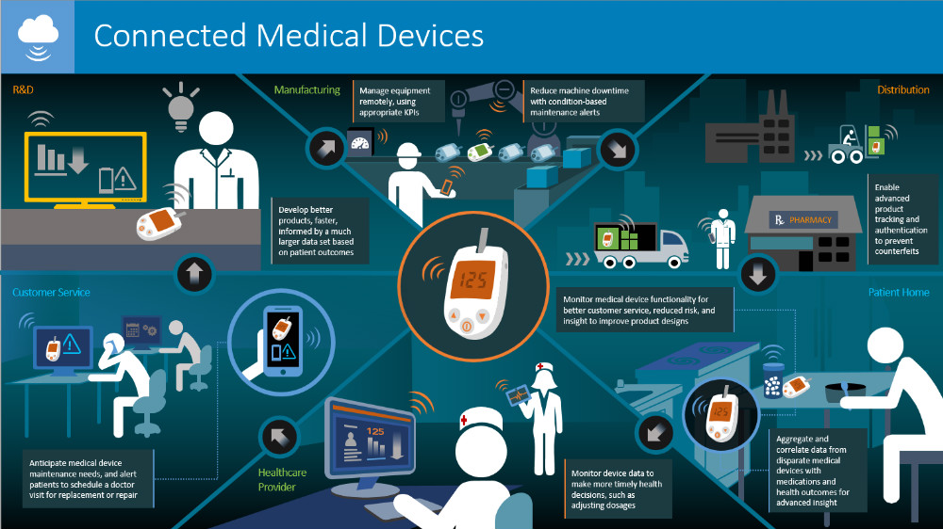

**Fig 1.1: Real Time Patient Monitoring**

* 1. **Motivation**

Heart Diseases have become one of the leading causes of death and World Health Organization states that cardiovascular diseases are the world’s largest killers causing death for 17.1 million people per year. In the recent years, world is experiencing high rate of heart diseases.

The number of elderly people in the world's population is increasing significantly. The number of people 60 years of age and over has been projected to reach approximately700 million by 2009 and 2 billion by 2050.

In a 2005 survey, most respondents—92%—recognized chest pain as a symptom of a heart attack. Only 27% were aware of all major symptoms and knew to call 9-1-1 when someone was having a heart attack.

About 47% of sudden cardiac deaths occur outside a hospital. This suggests that many people with heart disease don’t act on early warning signs.

The number of death can be decreased if the patient is monitored constantly for minimizing response time during an attack. As country like Bangladesh not every people are capable of visit to a doctor constantly and it’s really costly and time consuming for general people. Using our system, a patient needs not to be present to a doctor physically. In our system a patient can be monitored from home as patient’s vital information’s are processed through the system automatically. Doctor and relatives are notified by the system if patient suffers from a critical situation.

* 1. **Problem Statement**

In an aging society, heart attacks have huge consequences since they tend to cause tremendous concerns as related to deterioration in the quality of life and an increasing the cost of healthcare. Although there has been a great deal of research on automatic heart attack detection, the area of risk of heart attack prediction is still lacking in study and investigation. The need to identify all the possible patterns that can lead to a heart attack is very challenging.

Historically, seniors living all around the world have been known to be late adapters to the world of technology compared to their younger neighbors, but their movement into digital life is continuing to expand. Today, 59% of seniors report that they go online, and 47% say they have a high-speed broadband connection at home. In addition, 77%of them have a phone and among that number, 18% are using smartphone devices. With recent developments, smartphones have increased processing capabilities and are equipped with several built-in multimodal sensors, including accelerometers, gyroscopes, and GPS interfaces.

People who are aged can’t move from places to places frequently. There are many people live in rural areas don’t get much opportunity to visit doctor’s frequently. As everyone got at least a smart phone, so this system is possible to build for monitoring critical heart disease patient’s.

* 1. **Objective:**
* To introduce a system for real time monitoring heart disease patient’s that can minimize the response time in emergency situation.
* To develop a wireless body area network for monitoring heart rate of critical patient’s.
  1. **Thesis Organization**

The structure of rest of this report is described below:

**Chapter 2** describes the literature review and existing techniques of Real Time Heart disease patient monitoring.

**Chapter 3** represents the methodology, Diagrams and algorithms describing how this project is developed.

**Chapter 4** represents the real time implementation, results and decisions of this project.

**Chapter 5** describes the overall conclusion of this work precisely and future scope of work with this project.

**Chapter 2**

***Literacy Review***

**Materials**

In this Section, we will describe whole arrangement of our instruments where all the fundamental parts are discussed.

**2.1 Overview of Arduino:**

Arduino is a well-known microcontroller build on the ATmega328P. It contains some input and output pins by which it takes input to analysis the inputted data and give the analyzed data as output to its user. Among them 14 input and output pins 6 can be used as PWM output and 6 are used for analog input. There is a 16MHz quartz crystal, a USB connection, an ICSP header and a reset button. Every important parts are present here in order to support the function of microcontroller. In order to operate it the required power can be supplied by connecting it to a computer using USB cable or using an adapter or a battery.

Its durability is good and it can be repaired easily if anything goes wrong with the microcontroller. One just has to replace the chip which will cost a little to fixed the microcontroller. The Uno word was chosen to mark the release of IDE of Arduino. It is a software which is used to give command to the Arduino how it is going to analyze the inputted data. Using this software, the code for Arduino microcontroller is written, compiled and also can be tested. Then using this IDE this code is being burned to the microcontroller to perform a certain operation. Uno is the first microcontroller that uses USB among the Arduino board. Different types of sensors and modules can be connected to it and they can work together on a certain problem.

**2.1.1 Arduino Uno:**

Arduino Uno is a version of Arduino microcontroller family build on ATmega328P. Unlike all other microcontroller it also contains some input and output ports. By which it takes data from sensor and give analyze data to the user. Unlike other Arduino microcontroller it also contains 16MHz quartz crystal, a USB, an ICSP header and a reset button. Basically its power supply is given from the computer with which it is connected through USB data cable. This USB data cable is also used to burn the code based on which it will execute the analysis operation. In figure 2.1 introductory of structure of an Arduino is shown and in Fig 2.2 the parts are specifically shown.

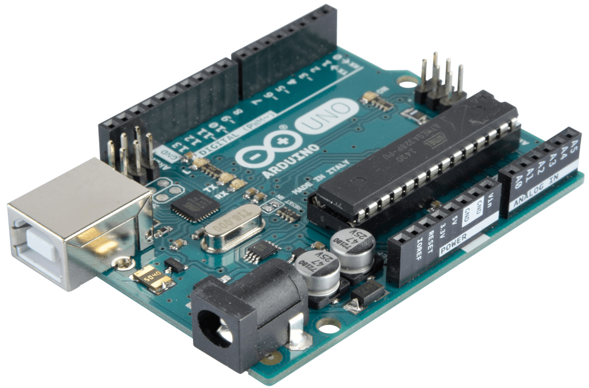

**Fig 2.1: Arduino Uno**

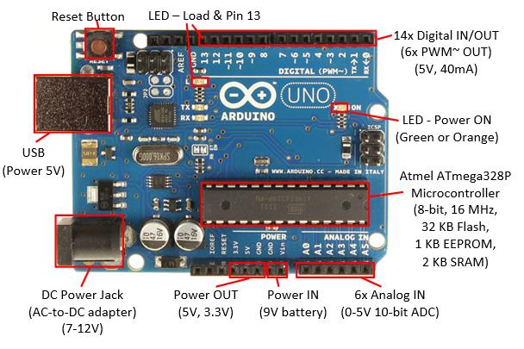

**Fig 2.2: Different parts of Arduino Uno**

**2.1.2 Specification of Arduino Uno:**

|  |  |
| --- | --- |
| Microcontroller | ATmega328P |
| Execution Voltage | 5V |
| Inputted Voltage (recommended) | 7-12V |
| Input Voltage (limit) | 6-20V |
| Digital I/O Pins | 14 (6 pins are used as PWM output) |
| PWM Digital I/O Pins | 6 |
| Analog Input Pins | 6 |
| DC Current per I/O Pin | 20 mA |
| DC Current for 3.3V Pin | 50 mA |
| Flash Memory | 32 KB of which bootloader use 0.5 KB |

**2.1.3 Power Supply**

As an electric device Arduino Uno needs power supply in order to operate its work and analyze the data. Power can be supplied to Arduino Uno using AC to DC adapter or battery. The most popular way of supplying power to Arduino Uno is using USB cable by which it is connected to the computer. The external power can be provided by the connector with a 2.1 mm center positive attachment to the board’s energy jack. On GND and power connector’s VIN stack header leads from the battery can be embedded. Between 6V to 20V this board can work. If it is connected under 7V, the 5V stick may have under 5V and the board might be unstable. If more than 12V are supplied, then the voltage controller may be overheated that can damage the board. So the ideal range is from 7V to 12V.

**2.1.4 Power Pins**

**VIN:** This pic is used when Arduino is using an outer power source. Voltage can be supplied through this pin. When voltage is provided by means of power jack then access it by this stick.

**5V:** This control the power supply of microcontroller and different segment of the board. This can be supplied from VIN by means of an on board regulator or provided by USB or other controlled 5V power supply.

**3.3V:** The on board FTDI chip produces a 3.3V supply and the max amount of current draw is 50 mA.

**GND:** Ground pin.

**2.1.5 Memory:**

In order to store the code, the AT mega 328 has 32 KB of flash memory of which 0.5 KB is used by the boot loader. Not only that, it contains a 2KB of SRAM and 1KB of EEPROM. Using EEPROM library this 1KB of EEPROM is read and written.

**2.1.6 Input and Output Pins:**

It will be easy to understand, if we describe the Arduino pins using a pin diagram. So the pin diagram of an Arduino is given below in Fig 2.3.

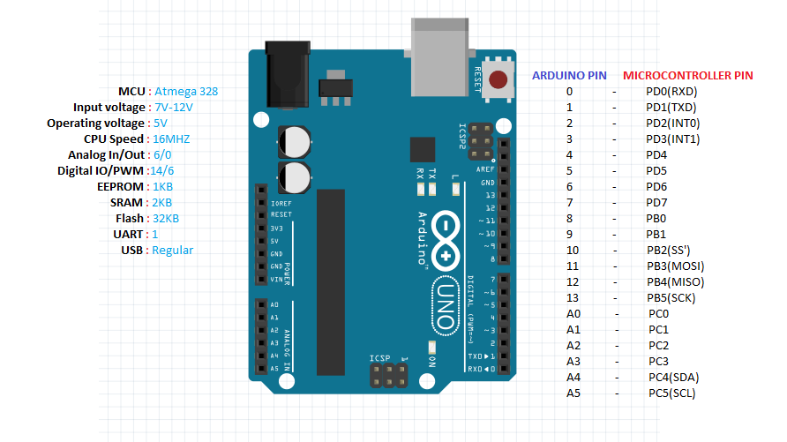**Fig 2.3: Input and Output Pin of Arduino.**

* Analogue Reference pin.
* Digital Ground pin.
* 0 and 1 are RXD and TXD pins. When we are about to use Arduino for serial communication this pins can’t be used as digital input pin.
* Digital input (pin 2 to 13).
* Analogue input (pin A0 to A5).
* There is a Power pin 5V (marked as 5V).
* Two ground pin (marked as GND left middle).
* Reset button (Top right red one0).
* External power supply (7V to 12V) (Top left).
* USB port.

As we mention earlier Arduino has 32 pin among them 6 are analogue and 14 digital pins. In order to use those digital pins as input and output we need the help of some functions like pin mode(), digital read() and digital write(). There is a maximum capacity of those pins and it is 40mA. Each of those pins have internal pull-up resistors of 20-50K ohms. Some of the pin can work on some special function.

**PWM:** 3,5,6 and 9-11 pins use analogue write() function to provide 8bit PWM output.

**SPI:** 10 (SS), 11 (MOSI), 12 (MISO), 13 (SCK). These pins bolster SPI correspondence, which although gave by the basic equipment, isn't right now incorporated into the Arduino dialect. The SPI pins are additionally broken out on the ICSP header.

**External interrupt:** 2 (interrupt 0), 3 (interrupt 1). This two pins are used to design trigger a hinder on a low esteem, a rising or falling esteem edge, or an adjustment in esteem.

**A4 (SDA) & A5 (SCL):** Support TWI communication utilizing the wire library (documentation on the wiring site).

**LED13:** There is a worked in Driven associated with computerized stick 13. at the point when the stick is HIGH esteem, the Drove is on, when the stick is LOW, it's off.

**Serial:** 0 (RX) and 1 (TX). Used to get (Rx) and transmit (TX) TTL serial information. Pins 0 and 1 are additionally associated with the comparing pins of the FTDI USB-to-TTL Serial chip.

6 analogue input of Arduino give 10bit of resolution. Its measurement range is ground to 5V by default. Though the upper range can be changed by AREF pin and analogue reference() function.

**AREF:** It provides the reference voltage while working on analogue input using analogue reference().

**Reset:** It take (RX) and transmit (TX) TTL serial information. Pins 0 and 1 are additionally associated with the comparing pins of the FTDI USB-to-TTL Serial chip.

**2.1.7 LEDs**

Arduino has four LEDs. They are L, RX, and TX and ON. Fig 2.4 shows the Arduino schematic diagram where LEDs are shown.

**RX and TX LEDs:** They indicate that the data is sent to the Arduino or not through the USB. The TX LED turned into yellow when the data sent from the Arduino to PC USB port. The RX LED turned into yellow when the data is sent from USB port to Arduino.

**ON LED:** This LED will illuminate green color when the Arduino is turned on. That means the power is supplied to the Arduino. This will indicate you that your Arduino is acting well. If this light is gleaming or turned off that means, there is a problem on the supply of power.

**L LED:** This is the only LED which can be controlled. Other LEDs are lighted up based on the current condition of the Arduino. This Led is associated with the Arduino principle chip and one can turn it on or off when you begin composing code and transferring on it.

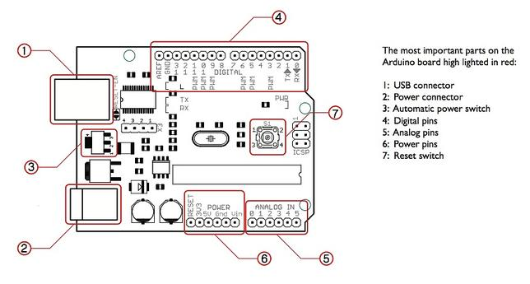

**Fig 2.4: Arduino Schematic Diagram.**

**2.2 Biomedical Sensor Pad:**

In order to measure the EEG, ECG and EMG levels one can use biomedical sensor pad which is a disposable electrode. There are so many heart related diseases when heart should be monitored most of the time. In this purpose these little pads can be very helpful for short-term monitoring of Neurofeedback and Biofeedback purposes. They are so popular among the users because of their integrated latex free gel. This gel will help the pad to adhere to our skin so that there will be no problem of taking the data from the heart. The snap of the connector is built in such a way that there is no difficulty to connect or remove it with the sensor cable’s electrode. Fig 2.5 is the picture of Biomedical Sensor Pad.

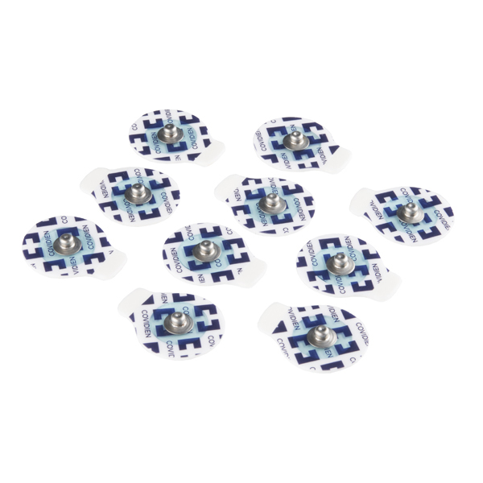

**Fig 2.5: Biomedical Sensor Pad.**

**2.2.1 Features of Biomedical Sensor pad**

* Light weight small size pad.
* Connector that connect the pad to the electrode.
* Latex free gel helps to adhere to the skin.
* Short-term useable.
* Helps to measure ECG, EEG and EMG levels.
* Dimensions: 24mm x 1mm.

**2.3 Sensor Cable - Electrode Pads**

# Among the three components which help to collect the ECG, EEG and EMG levels this one is the simplest one. It is simple in structure but its contribution in collecting data is not that much simple. With the help of the Biomedical sensor pad it collect the data and send it to the Single Lead Heart Rate Monitor - AD8232 for further process. If we see the Fig 2.6, it’s a 24” long cable with a feature of 3.5mm audio jack connector on one end and other end contain three snap style receptacles for Biomedical sensor pad. Each cable has a red, blue and a black electrode pad lead.

**2.3.1 Features of Sensor Cable - Electrode Pads**

* It passes the data from Biomedical sensor pad to AD8232.
* It has audio jack connector and snap style connector, which makes the connection with the biomedical sensor pad and heart rate monitor easier.
* 24” long.
* 3.5 mm audio jack.
* 3 electrode lead for better measurement.

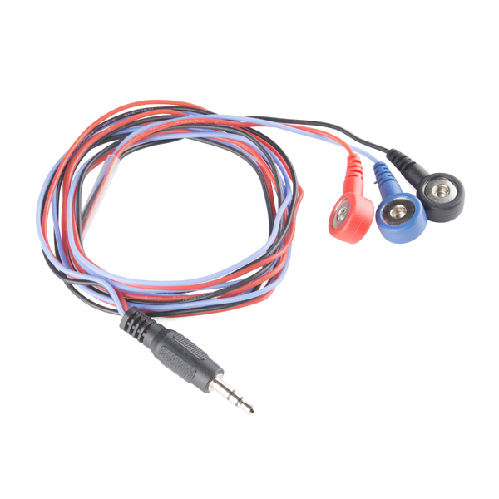

**Fig 2.6: Sensor Cable - Electrode Pads**

# 2.4 Single Lead Heart Rate Monitor - AD8232

# Single lead heart rate monitor AD8232 is a smart board which is cost effective and it’s used to measure the electrical activity measurement of the heart. This electrical activity can be charted as an ECG or Electrocardiogram and output as an analog reading. When we try to take the electrical activity of heart that data can be extremely noisy. So if we try to draw an ECG from that data we won’t be able to draw it perfectly. In order to draw a clear ECG signal from the PR and QT interval easily, this single lead heart rate monitor AD8232 works as an op amp. For ECG and other bio potential measurement applications, this AD8232 works as an integrated signal conditioning block. It is being designed in such a way that it can amplify, extract and filter small bio potential signal when there is a lots of possibility of noisy signal. For example, noisy signals created for motion or remote electrode placement. Fig 2.7 is the single lead heart rate monitor – AD8232.

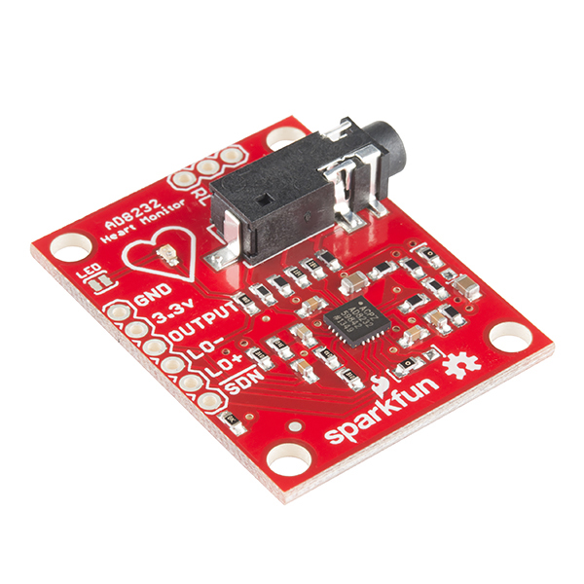

**Fig 2.7: Single Lead Heart Rate Monitor - AD8232**

**2.4.1 Pin connections:**

AD8232 heart rate monitor has nine pin connections from the board that you can solder pins, wires, or other connection. Pins are described using Fig 2.8 which shows the all the pins of AD8232.

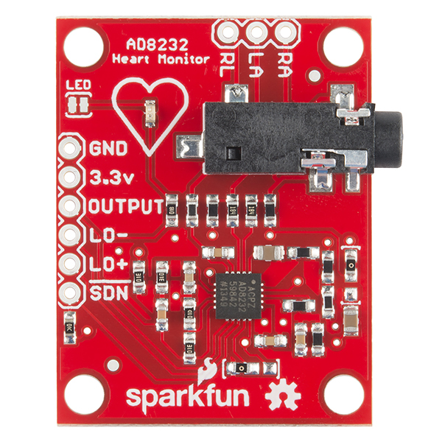

**Fig 2.8: Pins of AD8232**

* GND
* 3.3V
* Output
* LO-
* LO+
* SDN
* RA, LA and RL pins.

SDN, LO+, LO-, OUTPUT, 3.3V, GND provide essential pins provide essential pins that are required to operate the monitor with Arduino or any other development boards. This board also contains three more pins like RA (Right Arm), LA (Left Arm) and RL (Right Leg). These pins are used for user custom sensor. There is a LED attached to the monitor board which will pulse with the rhythm of the heartbeat. A schematic diagram of AD8232 is given in Fig 2.9.

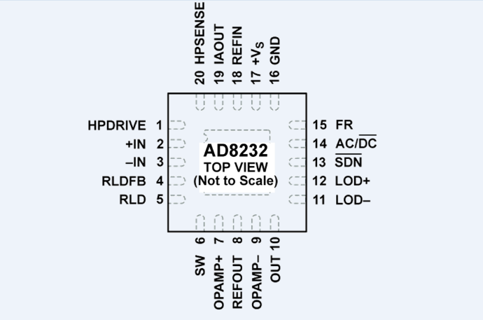

**Fig 2.9: Schematic Diagram of AD8232**

**2.4.2 Features of AD8232:**

* Measures the electric activity of heart.
* Used for amplifying noisy signal.
* It has 9 pin connections in order to work with Arduino or Other development board.
* RA, LA, RL pins are used for user custom sensors.
* It has an LED to indicate the Heart Beat.
* It has a 3.5mm audio port to connect with electrode pad.
* It works with Electrode pad and Biomedical sensor pad.

**2.5 HC-05 Bluetooth Module:**

The most popular Bluetooth SPP (serial port protocol) module is HC-05 module designed for wireless serial data communication system. This module can be used in two configurations those are known as master and slave configurations which made this data communication system a great medium. This serial port Bluetooth module is fully qualified Bluetooth V2.0+EDR (Enhanced Data Rate) 3Mbps Modulation with complete 2.4GHz radio transceiver and baseband. It uses CSR Blue core 04‐External single chip Bluetooth system with CMOS technology and with AFH (Adaptive Frequency Hopping Feature).

**2.5.1 About Bluetooth Module HC-05**

As we know that this module can work in two configurations but by default it is configured as slave. This configuration can be changed only by AT COMMANDS. The difference between the two configurations is, when it is configured to slave mode it cannot initiate a connection with other device. It can only accept connections when it is in slave mode. But in master mode configuration it can initiate connection

with other devices. In order to make a connection between MCU and GPS or PC to your embedded system or System to mobile the user can use this module as a serial port protocol. Top and bottom part of Bluetooth module is shown in Fig 2.10.

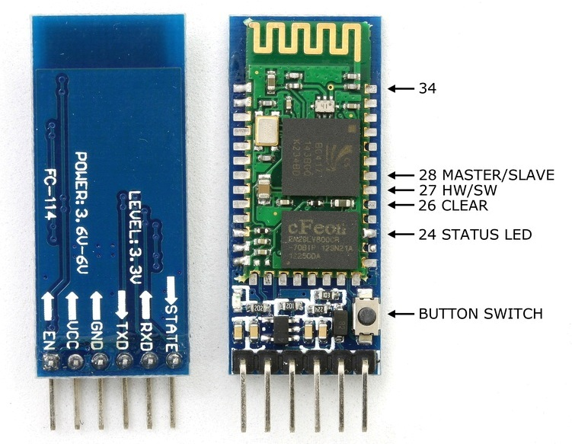

**Fig 2.10: Bluetooth Module.**

**2.5.2 Bluetooth Module Pins:**

There are 6 pins in Bluetooth module. They are given bellow in Fig 2.11:

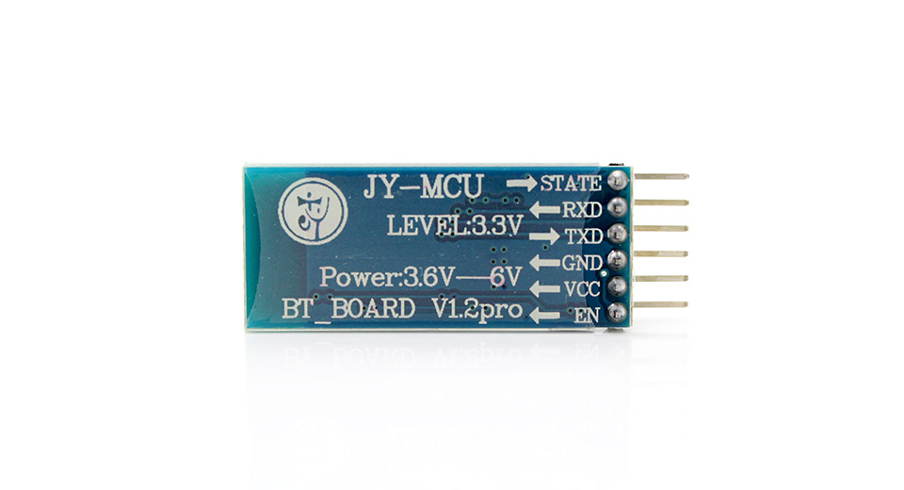

**Fig 2.11: Pin diagram of Bluetooth Module.**

**Enable (En):** When enable is pulled low the Bluetooth module is disabled and it will not be able to make any connection with other device as it is turned off. When enable is connected to 3.3V the module is turned on and it will make connection to other devices.

**VCC:** It is power supply pin of this module and the voltage range is 3.3V to 5V.

**GND:** It is the ground pin.

**TXD and RXD:** TXD and RXD pins are used for UART interface for communication.

**STATE:** It is used for indicating the state of the module. The signal goes low, when the module is not connected to or paired to other device. At this state the LED of the module flashes continuously which indicates that the module is not connected. When the module is connected to other device the state pin goes high. This time the LED flashes at a constant delay for example this delay can be 2s.

**Switch Button:** This helps the module to switch to AT COMMAND mode. To switch the AT COMMAND mode press the button for one second. By switching the mode user can change the parameters of this module but only if the module is not connected to other device. When it is connected to other device it remains busy to communicate with that device and fails to work on AT COMMAND mode.

**2.5.3 Features of Bluetooth module:**

* Typical ‐80dBm sensitivity.
* Up to +4dBm RF transmits power.
* 3.3 to 5 V I/O.
* PIO (Programmable Input/Output) control.
* UART interface with programmable baud rate.
* With integrated antenna.
* With edge connector.
* 2.4GHz radio transceiver and baseband.

**2.6 Survey of Existing Technique:**

During the working procedure we took a wide survey of existing techniques. We found some interesting paper which worked on related topic. Overviews of those papers are given below:

In paper [1] this article describes a body area network for measuring the electrocardiogram signal and transmitted it to a smartphone via Bluetooth for data analysis to a smartphone. The BAN uses a specially designed planar inverted F-antenna (PIFA) with a small form factor, realizable with low-fabrication cost techniques. From the characteristic of human body’s electrical properties, the antenna was designed in such a way that enables the surface wave propagation around the body. This system also uses the user’s mobile phone to analysis the sensor data and to generate the alarm, if any abnormality is detected. Those features are done by the android smartphone application.

In paper [3] the main focused is on IoT. As the popularity of IoT has increased and it has opened the door for an IoT solution for health care. Since one of the most prevalent healthcare problem today is the poor survival rate of out-of-hospital sudden cardiac arrests. In this paper they introduced a multisensory system using IoT physical activity like heart rate and body temperature. They build a system using sensors to collect data. After that by using signal processing and machine learning techniques on the collected data they try to predict sudden cardiac arrest or heart attack. These algorithms are implemented on smartphone.

|  |  |  |  |  |
| --- | --- | --- | --- | --- |
| Ref | System | Technique Used | Advantages | Disadvantages |
| 1 | WBAN  for Heart Attack Detection | ST Evaluation | Low Cost, Low Energy. | No Remote Monitoring, No Cloud |
| 2 | Continuous Change Detection in ECG | Markov-Model | Low Energy | No Remote Monitoring, No Cloud. |
| 3 | Prediction System of Cardiac Arrest | ST Evaluation | Emergency Responses System. | No Remote Monitoring, No Cloud. |
| 4 | Ambulant ECG  Monitoring | Pan-Tompkins | Low Cost | No Remote Monitoring, No Cloud. |

**Table 2.1: Comparison of Existing Techniques**

In paper [4] they work on ECG signal to interpret the wide range of heart condition. As we know that heart attack is a dangerous threat for human being and it can only be reduced by early warning which will reduce the heart damage and saving too much of the heart muscles. From this motivation this paper has developed a prototype application based on android platform to analyze the ECG to indicate the risk. They build up a device which will take the ECG data and send it via Bluetooth to mobile phone to analyze it farther. The have also tries to send the analyzed data to server for informing the doctor. Their main platform was to analysis the data via mobile phone as it is very easy to carry and using mobile phone it is possible to monitor one’s heart hate all the time.

In paper [6] the main purpose was to develop a wireless sensor network system that can regularly monitor and identify heart related diseases like cardiovascular experienced in patients at remote areas. They have to design a wearable wireless sensor system to continuously capture and transmit the ECG analogue data signal to the user’s mobile phone. Any abnormality will be notified to doctors, relatives and hospitals using the proposed data processing algorithm which is implemented on the user’s mobile phone. The complete data from the WWSS will also be sent to a central station, so that experts can provide some suggestion. In this process they have used sensor which will collect data and then process it on the WWSS if any abnormality has found then the notification will be sent to the selected persons. In order to analyze the signal, they have implemented algorithms on the mobile phone.

**Chapter 3**

***Design and Methodology***

**3.1 Healthcare Applications**

In addition to Healthcare services and applications deserve closer attention. It can be noted that services are used to develop applications, whereas applications are directly used by users and patients. Therefore, services are developer-centric, whereas applications, user-centric. In addition to applications covered in this section, various gadgets, wearable, and other healthcare devices currently available in the market are discussed. These products can be viewed as Healthcare innovations that can lead to various healthcare solutions. The next subsections address various Healthcare based healthcare applications, including both single- and clustered-condition applications.

**3.1.1 Heart Rate Monitoring:**

Heart rate data can be really useful whether you’re designing an exercise routine, studying your activity or anxiety levels or just want your shirt to blink with your heart beat. The problem is that heart rate can be difficult to measure.

The Pulse Sensor Amped is a plug-and-play heart-rate sensor for Arduino. It can be used by students, artists, athletes, makers, and game & mobile developers who want to easily incorporate live heart-rate data into their projects. It essentially combines a simple optical heart rate sensor with amplification and noise cancellation circuitry making it fast and easy to get reliable pulse readings. Also, it sips power with just 4mA current draw at 5V so it’s great for mobile applications.

Simply clip the Pulse Sensor to your earlobe or fingertip and plug it into your 3 or 5 Volt Arduino and you’re ready to read heart rate! The 24" cable on the Pulse Sensor is terminated with standard male headers so there’s no soldering required. Of course Arduino example code is available as well as a Processing sketch for visualizing heart rate data.

**3.2 Design Specification and Hardware:**

Following diagram Fig 3.1 shows the complete transmitter and receiver flow.

Here three sensors are connected to Arduino Uno,

* Biomedical Sensor pad which collects Electric Signal from human’s Body.
* Sensor Cable - Electrode Pads (3 connector) carries the Electrical signal of human body to AD8232 Serial Monitor.
* Single Lead Heart Rate Monitor - AD8232 measures the Electric activity of the Heart.

These sensors are connected to Arduino Uno where all that information is processed before sending. Then it is sent to Smartphone for data processing via HC-05 Bluetooth Module communication. Then the data is processed for detecting any anomalies present on patient Heart Beats. If any anomalies are present then a notification via SMS will be sent to the relatives of the patient. This mobile phone will also be able to send the processed data to a server from where doctors can monitor the patient any time and in case of emergency doctor can give immediate suggestions to the patient.

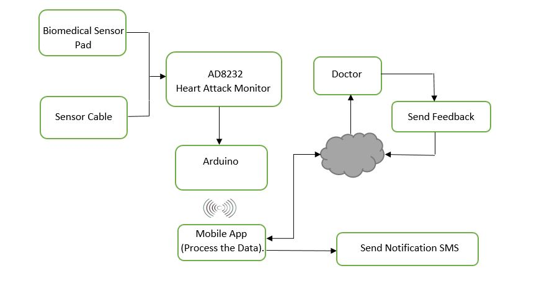**Fig 3.1: Block Diagram of the System**

**3.3 Hardware Connection**

Here we will discuss how the sensors and equipment’s are integrated to this system.

**3.3.1 Single Lead Heart Rate Monitor - AD8232:**

Fig 3.2 shows the connection of AD8232 with the Arduino Uno. The AD8232 is an integrated front end for signal conditioning of cardiac bio potentials for heart rate monitoring. It consists of a specialized instrumentation amplifier (IA), an operational amplifier (A1), a right leg drive amplifier (A2), and a mid-supply reference buffer (A3). In addition, the AD8232 includes leads off detection circuitry and an automatic fast restore circuit that brings back the signal shortly after leads are reconnected. The AD8232 contains a specialized instrumentation amplifier that amplifies the ECG signal while rejecting the electrode half-cell potential on the same stage. This is possible with an indirect current feedback architecture, which reduces size and power compared with traditional implementations.

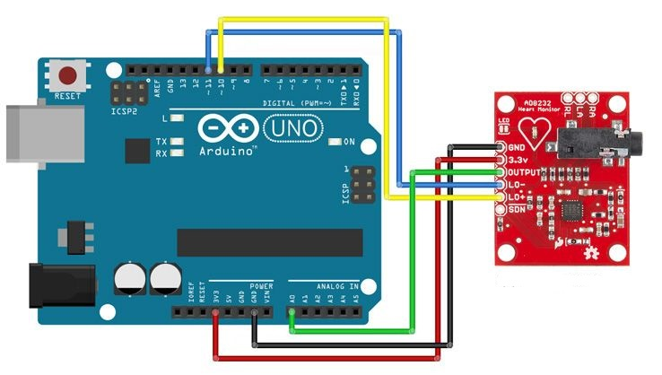

**Fig 3.2: AD8232 with Arduino**

The AD8232 is an integrated signal conditioning block for ECG and other bio potential measurement applications. It is designed to extract, amplify, and filter small bio potential signals in the presence of noisy conditions, such as those created by motion or remote electrode placement. This design allows for an ultralow power analog-to-digital converter (ADC) or an embedded microcontroller to acquire the output signal easily.

The AD8232 can implement a two-pole high-pass filter for eliminating motion artifacts and the electrode half-cell potential. This filter is tightly coupled with the instrumentation architecture of the amplifier to allow both large gain and high-pass filtering in a single stage, thereby saving space and cost.

An uncommitted operational amplifier enables the AD8232 to create a three-pole low-pass filter to remove additional noise. The user can select the frequency.

**3.3.2 Sensor Cable - Electrode Pads (3 connector)**

This is your simple three conductor sensor cable with electrode pad leads. These cables are 24" long and feature a 3.5mm audio jack connector on one end with snap style receptacles for biomedical sensor pads. Each cable comes in a red/blue/black set. This cable is connected to biomedical sensor pad and AD8232 as shown in Fig 3.3.

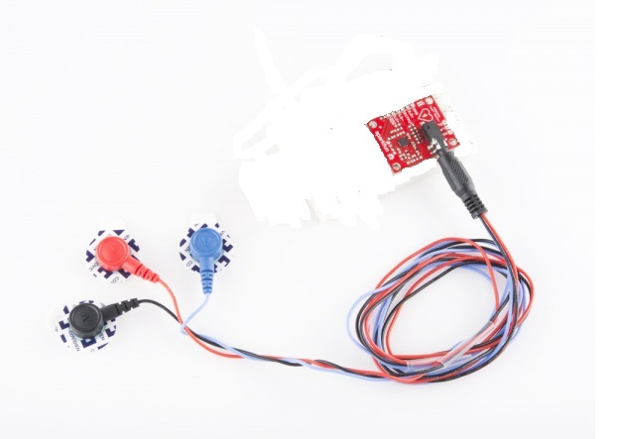

**Fig 3.3: Sensor Cable with AD8232**

**3.3.3 Biomedical Sensor Pads**

Biomedical Sensor Pads, disposable electrodes that can be used to measure EEG, ECG and EMG levels. these little pads are perfect for short-term monitoring of Neurofeedback and Biofeedback purposes. They are to be used once and are very handy because of integrated, latex-free gel. Each pad adheres very well to the skin and the snap connector can be pushed on or removed from the electrode lead with no issue. Those pads stay connected with sensor cable as shown in Fig 3.4.



**Fig 3.4: Biomedical Sensor Pad with Sensor Cable**

**3.3.4 HC-05 Bluetooth Module**

HC-05 Bluetooth Module is an easy to use Bluetooth SPP (Serial Port Protocol) module, designed for transparent wireless serial connection setup. Its communication is via serial communication which makes an easy way to interface with controller or PC. HC-05 Bluetooth module provides switching mode between master and slave mode which means it able to use neither receiving nor transmitting data. Connection of Bluetooth module with the Arduino is shown in Fig 3.5.

**3.3.5 Software features**

* Default Baud rate: 38400, Data bits:8, Stop bit:1, Parity: No parity, Data control: has.
* Supported baud rate: 9600,19200,38400,57600,115200,230400,460800.
* Given a rising pulse in PIO0, device will be disconnected.
* Status instruction port PIO1: low-disconnected, high-connected;
* PIO10 and PIO11 can be connected to red and blue led separately. When master and slave are paired, red and blue led blinks 1time/2s in interval, while disconnected only blue led blinks 2times/s.
* Auto-connect to the last device on power as default.
* Permit pairing device to connect as default.
* Auto-pairing PINCODE:”0000” as default
* Auto-reconnect in 30 min when disconnected as a result of beyond the range of connection.

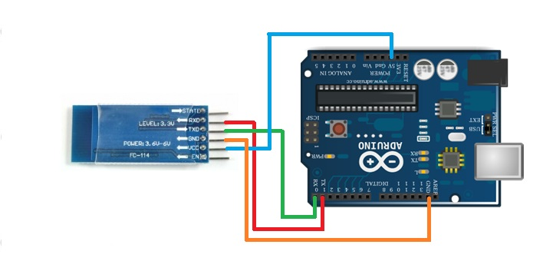**Fig 3.5: HC-05 Bluetooth Module with Ardiuno**

**3.4 Circuit Diagram**

This circuit Diagram in Fig 3.6 describes how this device will look like after integrating all the components. It also shows the connections of all components with each other.

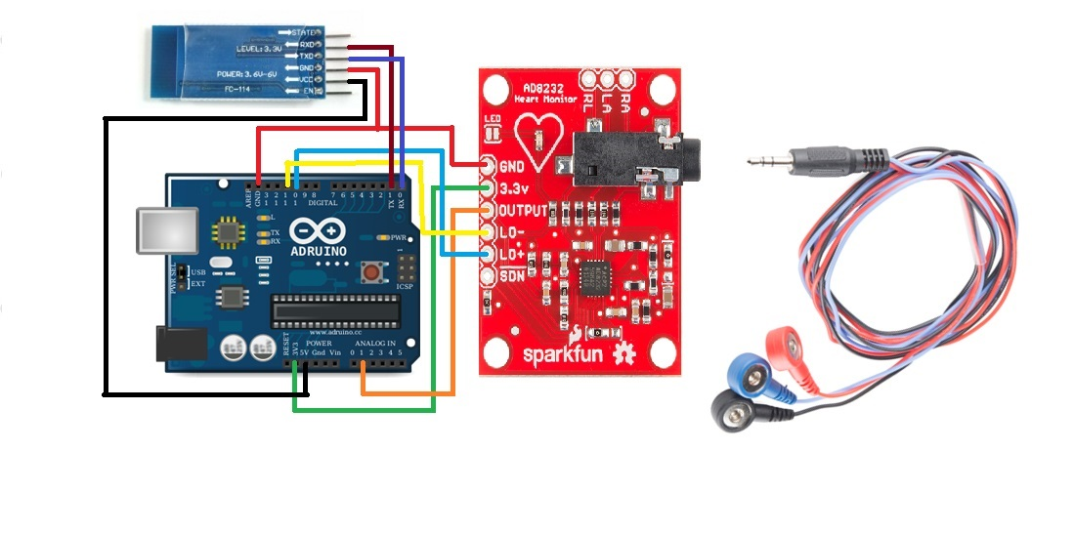**Fig 3.6: Circuit Diagram**

**3.5 Project Flow Diagram**

The flow diagram shows in Fig 3.7explain how the data is being collected by the sensors and sent it to the mobile phone for farther analysis. In the start stage the device will be active by providing power supply. Then the sensors will be active or initiated to collect the data. Then the collected data by the sensors will be brought to the Arduino for preliminary process which will be sent to the mobile. If the Bluetooth is connected to the mobile device, then the data will be sent to mobile else the data will not be sent. Then the working process of Arduino side is done.

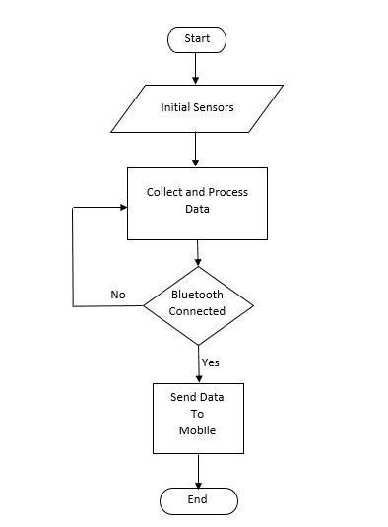

**Fig 3.7: Flow Diagram of Arduino**

Fig 3.8 explains how the received data from Arduino is processed and a notification is sent to the relatives by a Smart Mobile. After receiving the data mobile continuously analyze the data to find any abnormality. If Anomaly is detected then the Mobile send a notification as SMS to the relatives then one phase of the analysis is done. Then it again begins the analysis. If no Anomaly is detected then the mobile phone continuously keeps processing the analysis of the data.

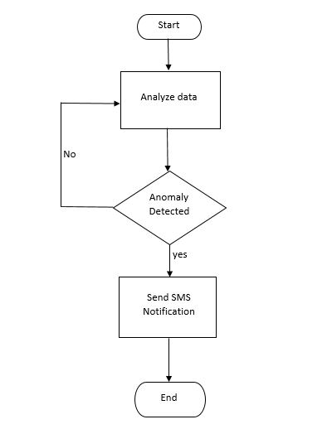

**Fig 3.8: Flow Diagram of Data Process**

**Chapter 4**

***Results and Decisions***

**4.1 Circuit Connections**

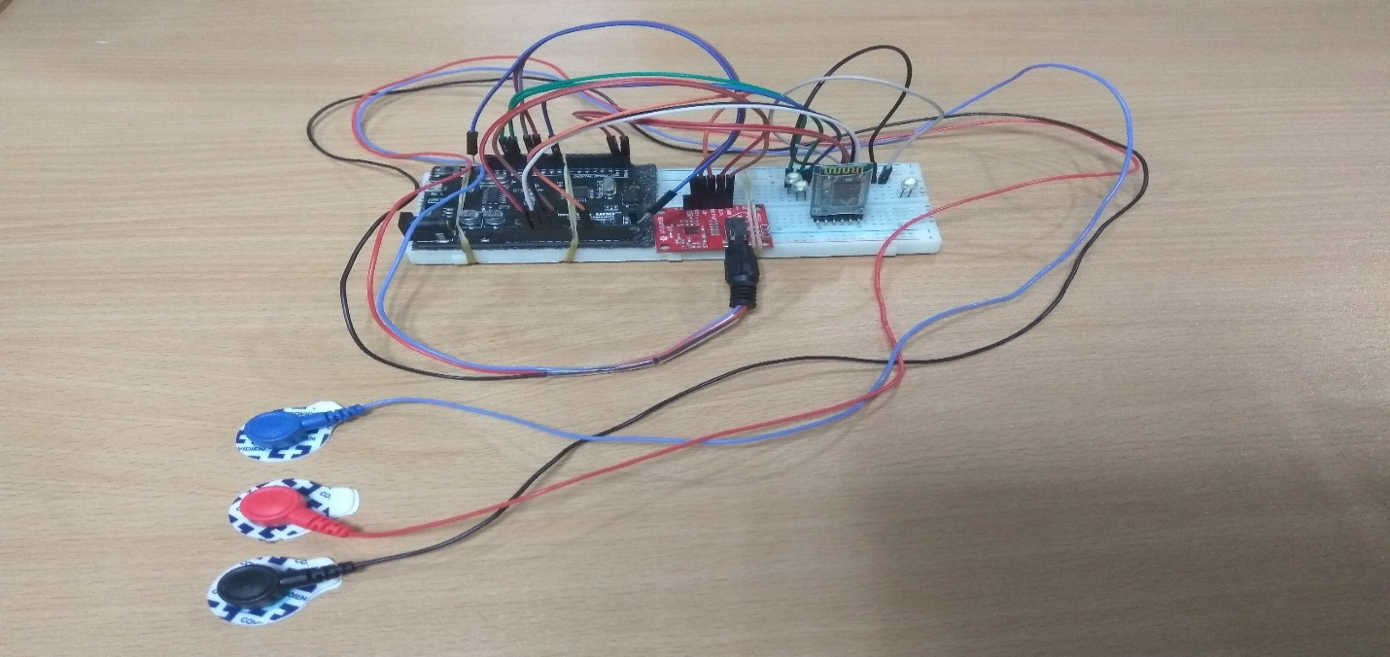

**Fig 4.1: Embedded device Actual Picture**

To develop the system, shown in Fig 4.1, we used Single Lead Heart Rate Monitor (AD8232), Sensor Cable - Electrode Pads (3 connector), Biomedical Sensor Pad (10 pack), HC-05 Bluetooth Module and Arduino Uno R3. Biomedical Sensor Pads are connected to Sensor Cable. These pads are responsible for collecting electrical signals from human heart and pass through the Sensor Cable. The Sensor Cable carries the electric signals to Single Lead Heart Rate Monitor. Single Lead Heart Rate Monitor filters the signal using High pass filtering and low pass filtering techniques. These filtering techniques are very much effective for cancelation of noise of the signal.

The AD8232 Heart Rate Monitor breaks out nine connections from the IC that you can solder pins, wires, or other connectors to. SDN, LO+, LO-, OUTPUT, 3.3V, GND provide essential pins for operating this monitor with an Arduino or other development board. Also provided on this board are RA (Right Arm), LA (Left Arm), and RL (Right Leg) pins to attach and use your own custom sensors. Additionally, there is an LED indicator light that will pulsate to the rhythm of a heartbeat. Biomedical Sensor Pads and Sensor Cable are required to use the heart monitor.

The 3.3V pin of Heart Rate Monitor is connected to 3.3V pin of Arduino.

**4.2 Real Time Monitoring**

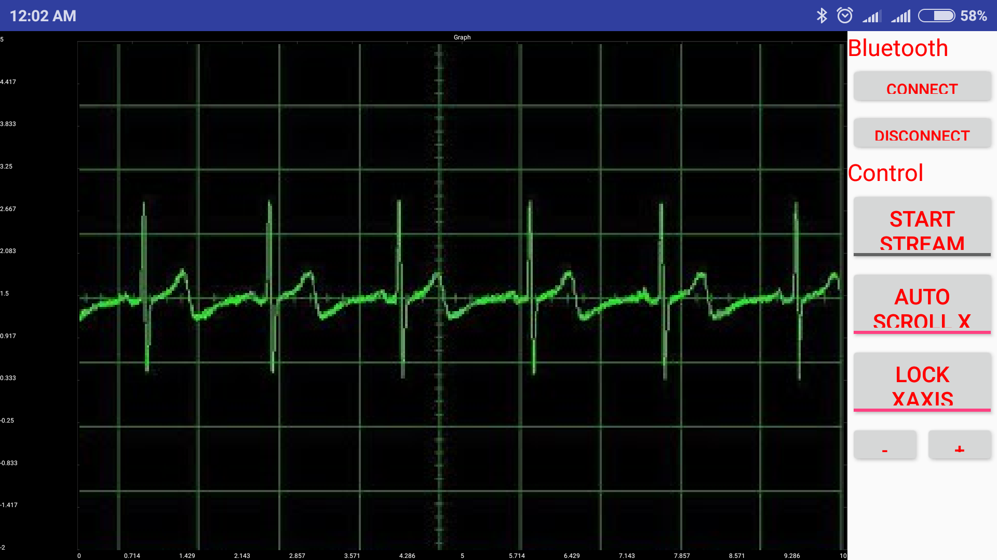

**Fig 4.2: Sample Mobile Interface (Landscape)**

This Project includes a system (web app) so that the doctor can monitor a patient’s Electrocardiography (ECG) using the system. If a patient got critical condition the will notify the patient’s relative as well as doctor. Then the doctor can immediately login to the system and monitor the patient’s Electrocardiography. If he finds anything suspicious, he can suggest some treatment immediately before visiting any doctor. Fig 4.2 shows the ECG signal of a patient.

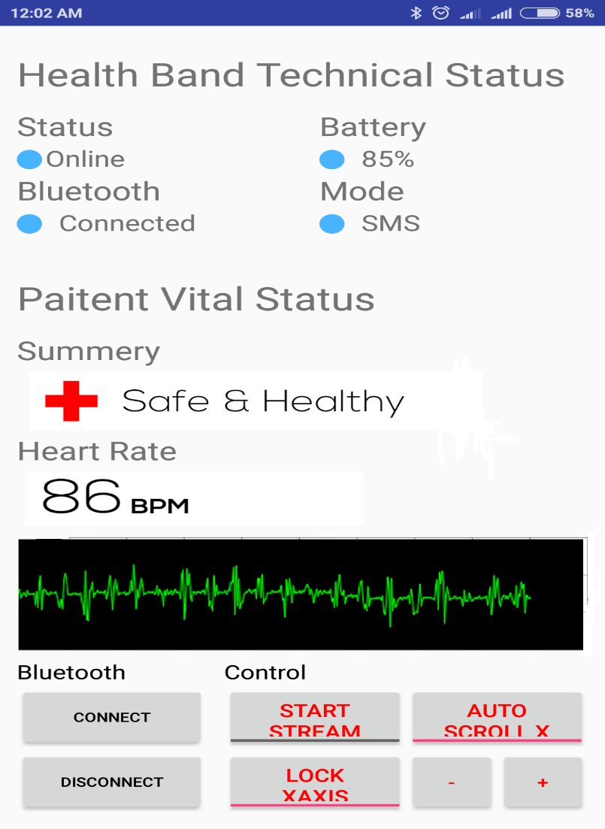

**Fig 4.3: Sample Mobile Interface (Portrait)**

This figure (Fig 4.3) is showing the mobile application of the system. The mobile application is responsible for receiving Electrocardiography signal from embedded device and process the signal to analyze the condition of patient. After analyzing if any anomalies found in the Electrocardiography of the patient, the system immediately notify the patient’s relative as well as the doctor appointed to him.

**4.3 Results and Decision**

In this Study we developed a mini embedded device to collect ECG signal from patient’s body to monitor and analyze it. We used a wireless body area network for real time detection of abnormalities in ECG. The implemented algorithm shows high accuracy to distinguish between normal and abnormal Electrocardiography patterns. The system can successfully detect abnormalities caused by brachycardia, tachycardia, and sinus arrhythmia.

|  |  |  |  |
| --- | --- | --- | --- |
| Patient ID | Actual Heart Rate | Detected Heart Rate | Accuracy (%) |
| 1 | 86 | 79 | 91.86% |
| 2 | 89 | 83 | 94.38% |
| 3 | 66 | 62 | 93.93% |
| 4 | 84 | 79 | 94.04% |
| 5 | 75 | 72 | 96% |

**Table 4.1: QRS Detection**

The system can detect QRS from Electrocardiography signal with a success rate of 94.6% from Electrocardiography signal taken from human body. From table -- , it can be concluded that the QRS detection algorithm is implemented well. We tested our system by putting the device to the patient’s chest and patients are allowed to move freely. The proposed system shows the good result in terms of success rate.

**4.4 Comparative Study**

|  |  |  |  |  |
| --- | --- | --- | --- | --- |
| Ref | System | Application | Benefits | Technique Used |
| 1 | WBAN  for Heart Attack Detection | Heart Attack Detection | Low Cost, Low Energy | ST Evaluation |
| 2 | Continuous Change Detection in ECG | Anomaly Detection | Low Energy | Markov-Model |
| 3 | Prediction System of Cardiac Arrest | Sudden cardiac arrest Detection | Low Energy | ST Evaluation |
| 4 | Ambulant ECG  Monitoring | ECG Monitoring | Daily activity recorder | Pan-Tompkins |
| 5 | Proposed System | Real Time ECG Monitoring | Low Cost, Remote Monitoring, Emergency alert System | QRS Detection |

**Table 4.2: Comparison Among Existing and Proposed System.**

The paper at [1] is mainly focused to transmit the Electrocardiography Signal to Mobile Application. This Study describes a body area network (BAN) for measuring an electrocardiogram (ECG) signal and transmitting it to a smartphone via Bluetooth for data analysis. The BAN uses a specially designed planar inverted F-antenna (PIFA) with a small form factor, realizable with low-fabrication cost techniques. Furthermore, due to the human body’s electrical properties, the antenna was designed to enable surface-wave propagation around the body. The system utilizes the user’s own smartphone for data processing, and the built-in communications can be used to raise an alarm if a heart attack is detected. This is managed by an application for Android smartphones that has been developed for this system. The good functionality of the system was confirmed in three real-life user case scenarios.

The paper at [2] developed wireless body area networks (WBANs) for healthcare and remote monitoring have brought a revolution in the medical research field. Numerous physiological sensors are integrated in a WBAN architecture in order to monitor any significant changes in normal health conditions. This monitored data is then wirelessly transferred to a centralized personal server (PS). However, this transferred information can be captured and altered by an adversary during communication between the physiological sensors and the PS. Another scenario where changes can occur in the physiological data is an emergency situation, when there is a sudden change in the physiological values, e.g., changes occur in electrocardiogram (ECG) values just before the occurrence of a heart attack. This paper presents a centralized approach for the detection of abnormalities, as well as intrusions, such as forgery, insertions, and modifications in the ECG data. A simplified Markov model-based detection mechanism is used to detect changes in the ECG data. The features are extracted from the ECG data to form a feature set, which is then divided into sequences. The probability of each sequence is calculated, and based on this probability, the system decides whether the change has occurred or not. The experiments and analyses show that the proposed scheme has a high detection rate for 5% as well as 10% abnormalities in the data set.

The paper at [3] developed an embedded IoT system to monitor heart rates and body temperatures using smartphones. ECG sensor system is used and the real time detection of abnormality in users’ ECG patterns. The results from sensors’ data are also presented to show that this approach provides a high rate of classification correctness in distinguishing between normal and abnormal ECG patterns. The system may also find multiple applications in heart behavior detection for people with various disabilities who are at a high risk of cardiac arrest. To test the permanence and long-term feasibility of our approach in the future, we plan to test our system with data from elderly people who suffer from chronic heart problems. Additionally, the system can be used in smart home monitoring systems for future wireless technologies.

In this work [4], an android application was proposed which can continuously receive ECG signals from acquisition device wirelessly, detect QRS complex, compute heart rate and plot the real time ECG signal on mobile phone for displaying. Also, it can send this information to concerned physician via server for medical decision. Experiments show that the proposed system is unobtrusive and can be comfortably used by the user during daily activities. The paper sets a foundation for future developments that can improve proposed application for wireless health solutions. Some of the features that can be included are detection of irregularities in the rhythms of the heart, monitoring and analyzing ECG signals at home and simultaneous automatic alert to the doctor of any emergencies. It is also important to include more options like zooming functionality, which will improve the usability of the app.

In this study [5] proposed low cost wireless communication have greatly assisted in coping with the problem of fewer medical facilities. The main purpose of this research work is to develop a wireless sensor network system that can continuously monitor and detect cardiovascular disease experienced in patients at remote areas. One of the most prevalent healthcare problems today is the poor survival rate of out-of-hospital sudden cardiac arrests. The Objective of this study is to present a Wearable Body Area Network System to continuously capture and sent the ECG signal to patient’s Mobile Phone. By analyzing the signal critical situation will be identified and alert will be sent to doctor, relatives and Ambulance services using data processing algorithm implemented on patient’s mobile phone. A wireless transmission system is also proposed for continuous data transmitting to a server system where a doctor can monitor the patient Electrocardiography (ECG) from a long distance. In this project we developed a wearable ECG device and a real time brachycardia, tachycardia, and sinus arrhythmia detection based android mobile application. ECG signals from patient’s body is collected by the mini ECG device and sent through a Bluetooth module to Android Mobile Application. On Android application processed data analysis based Pan Tompkins algorithms to detect complex QRS ECG signal and heart beats. From the number of heart rate can be detected abnormalities. Upon completing the system, we tested the system using signals generated by Fluke PS400 and real data. There are three categories of abnormalities under study: brachycardia, tachycardia, and sinus arrhythmia. Normal heart signal is also included in the test. We have tested this application in real time by collecting the ECG from the patient in stationary as well as simulated data. In both situations the application fulfils requirements of the proposed system.

**4.5 Conclusion**

Most of the study, we discussed, have some flaws such as cloud storage and there is no remote monitoring system so that the doctor or physician can observe the Electrocardiography of the patient’s from a distance place. This is a big advantage of Real Time monitoring. In case of any Emergency, the system will generate an alert message to doctor, relative, Ambulance services etc. When the doctor will get an alert message, he will have an opportunity the check the Electrocardiography to observe how much critical condition the patient have and can suggest some emergency medicines so that the patient can buy some time. We also proposed a cloud server to patients ECG signal for later analysis. The system is now under testing phase. We tested the system using real time and simulated data and the system yield high accuracy in both cases.

**Chapter 5**

***Conclusion***

**5.1 Overall Conclusion**

In this process, the system can be developed for monitoring real time heart disease patients. The information of Electrocardiography goes to the cloud server so that a doctor can observe it without the patient. Our system will be life saver as it minimizes the response time by providing early warning at critical situation. Using the proposed algorithm, the system can successfully detect any anomalies of patient’s heart beats and ask for emergency help. To analyze the Electrocardiography, the patient need not to be present before doctor. Using the smart algorithm, the system will analyze the data and tell the user’s what to do. If the system is developed in future under proper guidance and funding by heart institute like “National Heart Foundation” a massive number of critical heart patient will be benefited.

**5.2 Future Work**

Future work in this system can be use of more Electro pads for better Electrocardiography (ECG) signal. The system can be developed is such a way that the doctor can suggest some treatment through the system in case of life threatening situation. Machine learning technique like classification can be used to improve more accuracy to detect anomalies in Electrocardiography. Here is the list of work that can be done to improve the system.

* Develop a system for doctor to suggest patient in case of life threatening situation of patient.
* Maintain a cloud server to store the record patient’s information and Electrocardiography.
* Use of BITalino (r)evolution Board Kit for more accurate Signal.

**References**

|  |  |
| --- | --- |
| [1] | Georg Wolgast, Casimir Ehrenborg, Alexander Israelsson, Jakob Helander, Edvard Johansson, and Hampus Månefjord, “Wireless Body Area Network for Heart Attack Detection” IEEE Antennas & Propagation Magazine, October 2016. |
| [2] | FARRUKH ASLAM KHAN, NUR AL HASAN HALDAR, AFTAB ALI1,  MOHSIN IFTIKHAR, TANVEER A. ZIA, ALBERT Y. ZOMAYA, “A Continuous Change Detection Mechanism to Identify Anomalies in ECG Signals for WBAN-Based Healthcare Environments” IEEE Access , June 2017. |
| [3] | Yosuf ElSaadany, AKM Jahangir A. Majumder, Donald R. Ucci, “A Wireless Early Prediction System of Cardiac Arrest through IoT” IEEE 41st Annual Computer Software and Applications Conference, 2017. |
| [4] | Prerana N Gawale, A N Cheeran, Nidhi G Sharma, “Android Application for Ambulant ECG Monitoring”, International Journal of Advanced Research in Computer and Communication Engineering Vol. 3, Issue 5, May 2014. |
| [5] | Prerana N Gawale, A N Cheeran, Nidhi G Sharma, “Android Application for Ambulant ECG Monitoring,” International Journal of Advanced Research in Computer and Communication Engineering Vol. 3, Issue 5, May 2014. |
| [6] | Kala John Kappiarukudil, Maneesha Vinodini Ramesh, “Real-Time Monitoring and Detection of ‘‘Heart Attack’’ Using Wireless Sensor Networks,” 2010 Fourth International Conference on Sensor Technologies and Applications. |
| [7] | J. Pan and W.J. Tompkins, “A real-time QRS detection algorithm”, IEEE Trans. Biomed. Eng., vol. BME-32, pp. 230-236, 1985. |
| [8] | Noureddine Belgacem, Fethi Bereksi-Reguig, “Bluetooth Portable Device for ECG and Patient Motion Monitoring”, Nature & Technology Review. Issue n° 04/January 2011. Pages 19 to 23. |
| [9] | “World population prospects the 2008 revision: Volume I: Comprehensive  tables,” United Nations, Dept. Econ. Soc. Affairs, Population Division,  New York, NY, USA, Tech. Rep. ST/ESA/SER.A/287, 2009. |
| [10] | Jimena Rodríguez, Lacramioara Dranca, Alfredo Goñi and Arantza Illarramendi, “A Wireless Application That Monitors Ecg Signals On-Line: Architecture And Performance”, ICEIS 2004 - Software Agents And Internet Computing. |
| [11] | Meiran Peng, Tiandong Wang, Guangshu Hu, Hui Zhang, “A wearable heart rate belt for ambulant ECG Monitoring”, The 2012 IEEE 14th International Conference on e-Health Networking, Applications and Services (Healthcom). |
| [12] | A. Wood et al., “ALARM-NET: Wireless sensor networks for assisted-living residential monitoring,” Dept. Comput. Sci., Univ. Virginia, Charlottesville, VA, USA, Tech. Rep., 2006. |